**PROJECT WORKSHOP 3**

**SCOPE: CREATE TRAVEL EXPERT AGENCY DATABASE**

**TEAM MEMBERS: FEMI ADAMS**

**HERMELA YIMER**

**NKEM MBACHU**

**TABLE OF CONTENT**

**DISK CONFIGURATION BLUEPRINT……………………………………………….Page2**

**STEPS TAKEN TO CREATE DATABASE………………………………………….Page3-9**

**REFERECES……………………………………………………………………………Page10**

**DISK CONFIGURATION BLUEPRINT**

|  |  |
| --- | --- |
| **DISK NAME** | **DESCRIPTION** |
| Disk C | Operating System  InitTEA  Pfile  Backups  Temp\createTEA.sql |
| Disk D | User Database Data Files  Controlfile  Datafile  Onlinelog |
| Disk E | User Database Log Files  Controlfile  Datafile  Onlinelog |
| Disk F; | System Databases  Controlfile  Datafile  Onlinelog |

**STEPS TAKEN TO CREATE THE DATABASE**

**Step 1:**

Create init.ora file which has 3 control files stored on different disk space.

C:\Oracle\db\19C\database\initTEA.ora is the directory path on Windows OS where the file is stored

**db_name= TEA**

**control_files='D:\Oracle\Oradata\TEA\controlfile\Control01.ctl','E:\Oracle\Oradata\TEA\controlfile\Control02.ctl', 'F:\Oracle\Oradata\TEA\controlfile\Control03.ctl'**

**db_block_size=8192**

**db_domain=femi.saitclass.com**

**memory_target=2g**

**pga_aggregate_target=1g**

**undo_tablespace=UNDOTS**

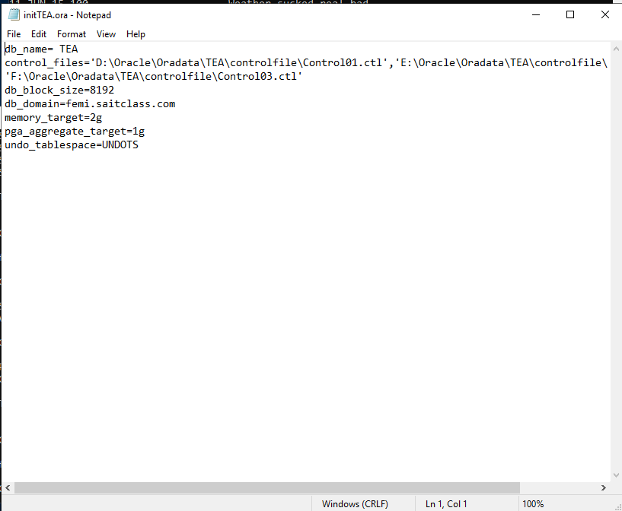

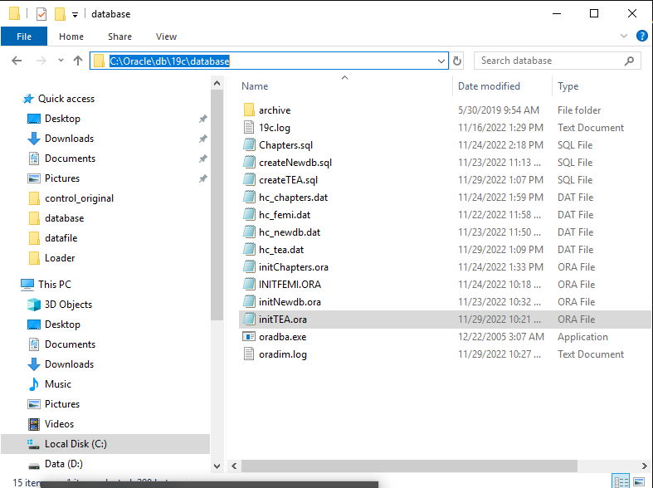

**Step 2:**

Create the Windows Service for the database instance by running this script in sqlplus

**TEA- stands for Travel Expert Agency**

**Pfile is the same as init.ora file**

**oradim -new -sid TEA -pfile c:\Oracle\db\19C\database\initTEA.ora**

**startup nomount**

**Step 3:**

Start up the new database instance in no mount stage.

Run startup nomount in sqlplus

Hint: You need to connect to the database as SYSTEM before running this script

**Step 4:**

Write the code that specifies the parameters the database must follow.

C:\Temp\createTEA.sql is the code that creates the database and it is stored in temp directory on C drive

**CREATE DATABASE TEA**

**USER SYS IDENTIFIED BY Password1**

**USER SYSTEM IDENTIFIED BY Password1**

**LOGFILE GROUP 1 ('d:\Oracle\oradata\TEA\onlinelog\redo01a.log') SIZE 10M BLOCKSIZE 512,**

**GROUP 2 ('e:\Oracle\oradata\TEA\onlinelog\redo02a.log') SIZE 10M BLOCKSIZE 512,**

**GROUP 3 ('f:\Oracle\oradata\TEA\onlinelog\redo03a.log') SIZE 10M BLOCKSIZE 512**

**MAXLOGFILES 5**

**MAXLOGMEMBERS 5**

**MAXLOGHISTORY 1**

**MAXDATAFILES 100**

**MAXINSTANCES 1**

**CHARACTER SET US7ASCII**

**NATIONAL CHARACTER SET AL16UTF16**

**EXTENT MANAGEMENT LOCAL**

**DATAFILE 'd:\Oracle\oradata\TEA\datafile\system01.dbf' SIZE 500M**

**SYSAUX DATAFILE 'e:\Oracle\oradata\TEA\datafile\sysaux01.dbf' SIZE 500M**

**DEFAULT TABLESPACE users DATAFILE 'f:\Oracle\oradata\TEA\datafile\users01.dbf' SIZE 500M**

**DEFAULT TEMPORARY TABLESPACE tempts TEMPFILE 'd:\Oracle\oradata\TEA\datafile\temp01.dbf' SIZE 200M**

**UNDO TABLESPACE undots DATAFILE 'e:\Oracle\oradata\TEA\datafile\undotbs01.dbf' SIZE 200M;**

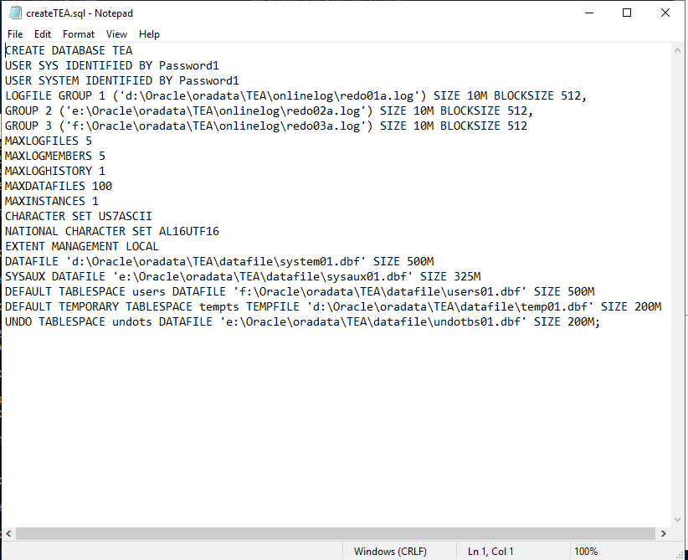

**Step 5:**

Create the database by running this script in sqlplus

**@c:\Temp\createTEA.sql**

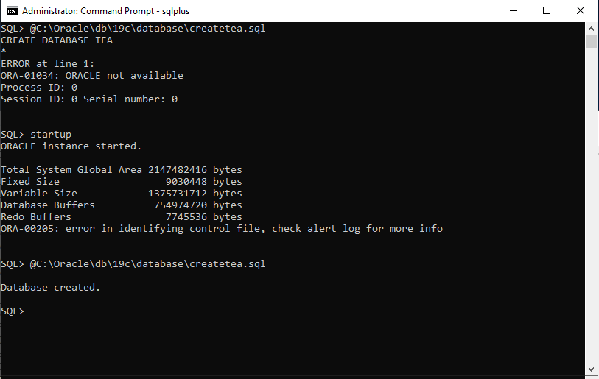

**Step 6:**

Run a script called catalog.sql in sqlplus

The path for this script is C:\Oracle\db\19c\rdbms\admin

Purpose: it creates the views of the data dictionary tables, the dynamic performance views, and public synonyms for many of the views. Grants PUBLIC access to the synonyms.

**@c:\Oracle\db\19C\rdbms\admin\catalog.sql**

**Step 7:**

Run a script called catproc.sql in sqlplus

The path for this script is C:\Oracle\db\19c\rdbms\admin

Purpose: runs all scripts required for or used with PLSQL.

**@c:\Oracle\db\19C\rdbms\admin\catproc.sql**

**Step 8:**

Run a script called pupbld.sql in sqlplus

The path for this script is C:\Oracle\db\19c\sqlplus\admin

Purpose: Script to install the SQL*Plus PRODUCT_USER_PROFILE tables.

**@c:\Oracle\db\19C\sqlplus\admin\pupbld.sql**

**Step 9:**

Run a sql query to show v$controlfile and block size in sqlplus

Purpose: this displays the names of the control files.

**select name from v$controlfile;**

**select block_size from v$controlfile;**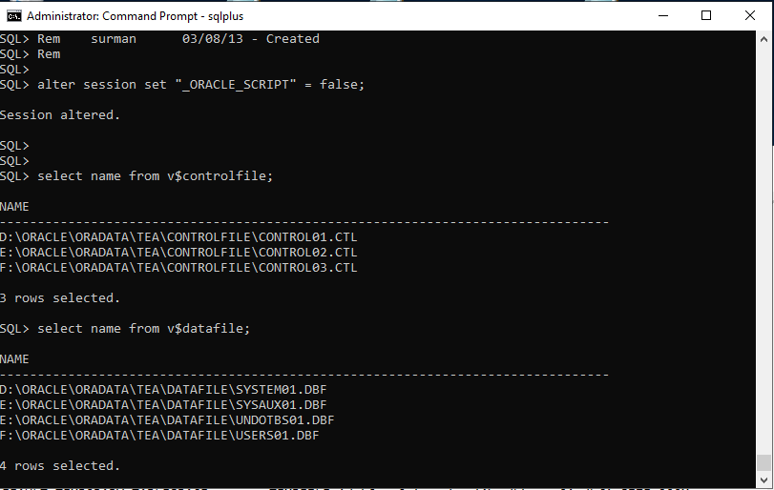

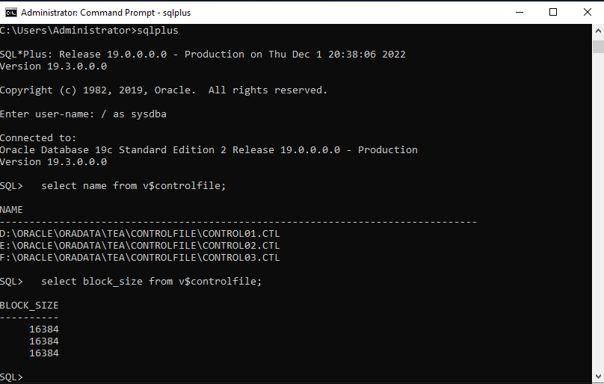

**Step 10:**

Run a sql query to show v$datalfile in sqlplus

Purpose: this displays datafile information from the control files.

**select name from v$datafile;**



**Step 11:**

Run a sql query to show v$logfile in sqlplus

Purpose: it contains information about red log files.

**desc v$logfile**

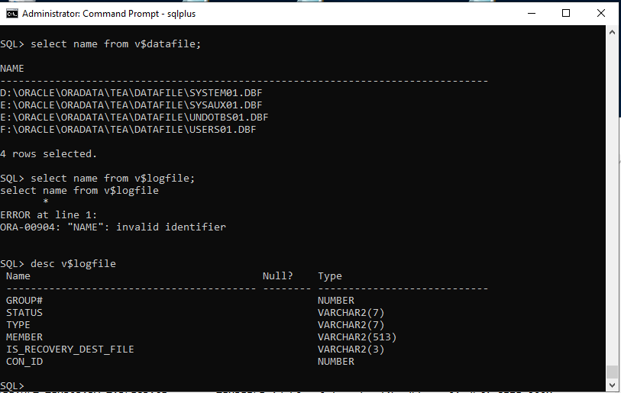

**Step 12:**

Run a sql query to show tablespaces in sqlplus

Purpose: tablespace is where logical data is stored in the database.

**Select tablespace_name from dba_tablespaces;**

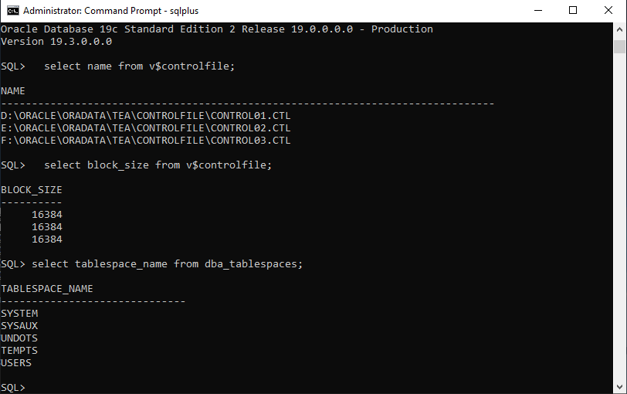

**REFERENCES**

**STEP 6:** [Catalog.sql and catproc.sql — oracle-tech](https://community.oracle.com/tech/developers/discussion/1102366/catalog-sql-and-catproc-sql)

**STEP 7:** [Catalog.sql and catproc.sql — oracle-tech](https://community.oracle.com/tech/developers/discussion/1102366/catalog-sql-and-catproc-sql)

**STEP 8:** [Pupbld.sql — oracle-tech](https://community.oracle.com/tech/developers/discussion/2387813/pupbld-sql)

**STEP 9:** [V$CONTROLFILE (oracle.com)](https://docs.oracle.com/en/database/oracle/oracle-database/19/refrn/V-CONTROLFILE.html#GUID-C285E8C5-6A2D-44B1-BDF8-F880B5F088C4)

**STEP 10:** [V$DATAFILE (oracle.com)](https://docs.oracle.com/en/database/oracle/oracle-database/19/refrn/V-DATAFILE.html#GUID-7BF7955C-9705-40F4-B2F6-5D7F3A32DD30)

**STEP 11:** [V$LOGFILE (oracle.com)](https://docs.oracle.com/en/database/oracle/oracle-database/19/refrn/V-LOGFILE.html#GUID-AE0B85B3-6B51-4FBD-A460-2D7090D9E0B5)